Follow-up analysis by MD and DL

**Protocol-driven prevention of perioperative hypothermia in the pediatric neurosurgical population**

Dr. Ian Mutchnick

There are a few discrepancies we would like to point out in the Results section.

* At 1 hour, we have 11 and 43 patients with at least one hypothermic event for the WG and CG, respectively, where you have 12 and 42.
* At 2 hours, we have 12 and 45 patients with at least one hypothermic event for the WG and CG, respectively, where you have 14 and 47.

P-values change but conclusions do not from these discrepancies.

The following plot compares the mean temperatures between the WG and CG prior to imputing missing values. There is an artificial drop at time 0 for the WG due to the missingness and one extreme value.

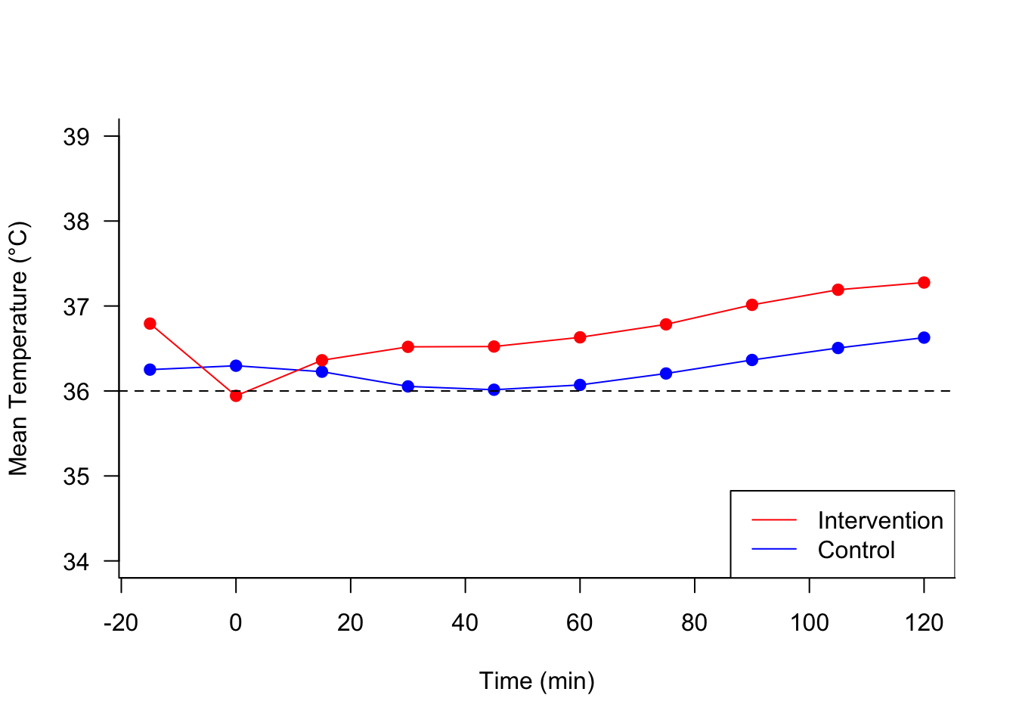

Looking at the same plot but with imputed values. The effect of the extreme value on the mean is muffled due to the increased sample size at time 0 from the imputation. Note the similar curve shapes between groups. Interpretation: initial temperature plays a key role in preventing hypothermia because, on average, patients experience a similar dip in temperatures during the perioperative time frame.

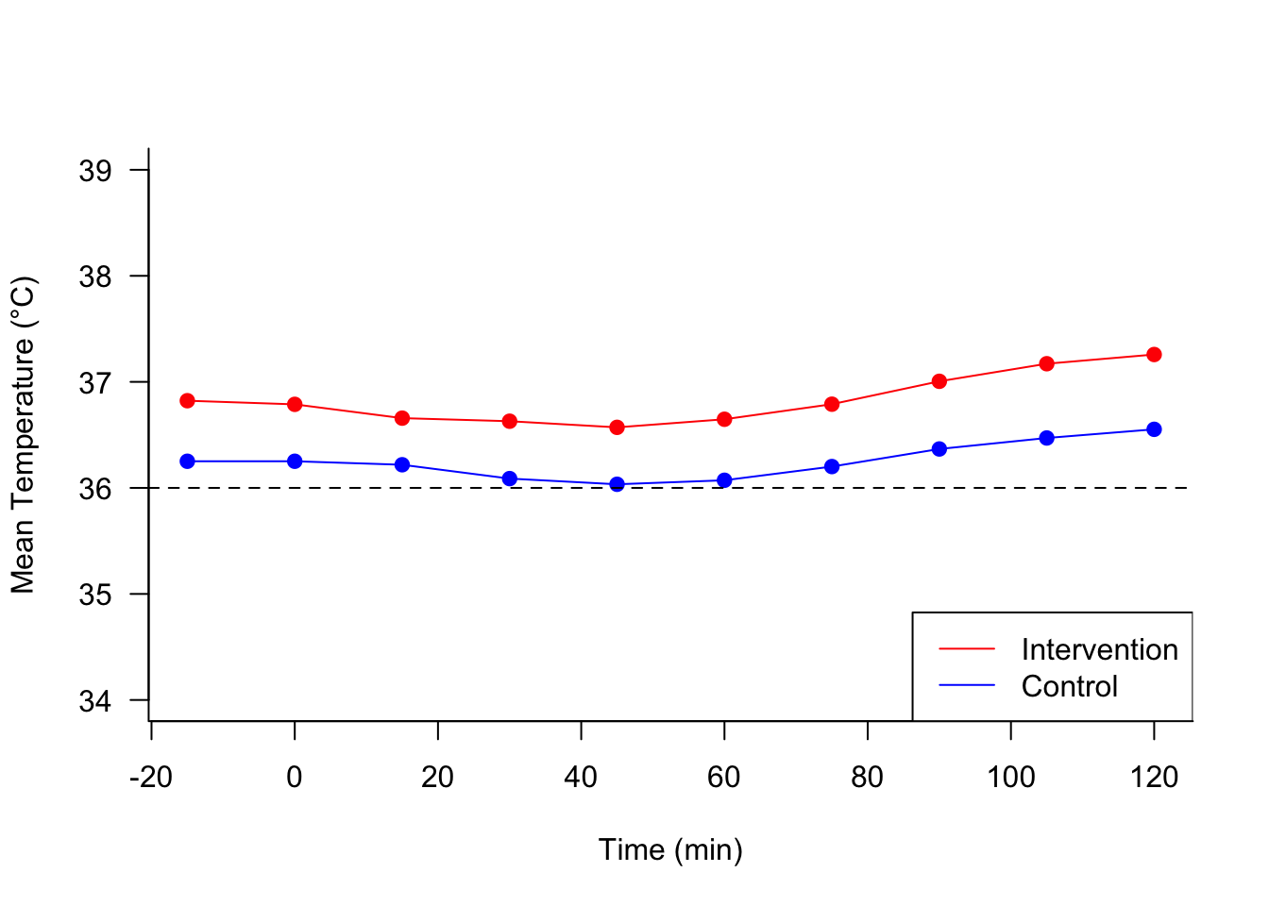

These spaghetti plots reflect the temperature behavior of individual patients within each group. The flat lines are a relic of the carry value forward algorithm for the missing temps. Subjectively looking at the graphs, both groups tend to have more patients above the hypothermic cutoff than below and the intervention group has higher temps on average. (extreme temp of 22.7 not included in plot)

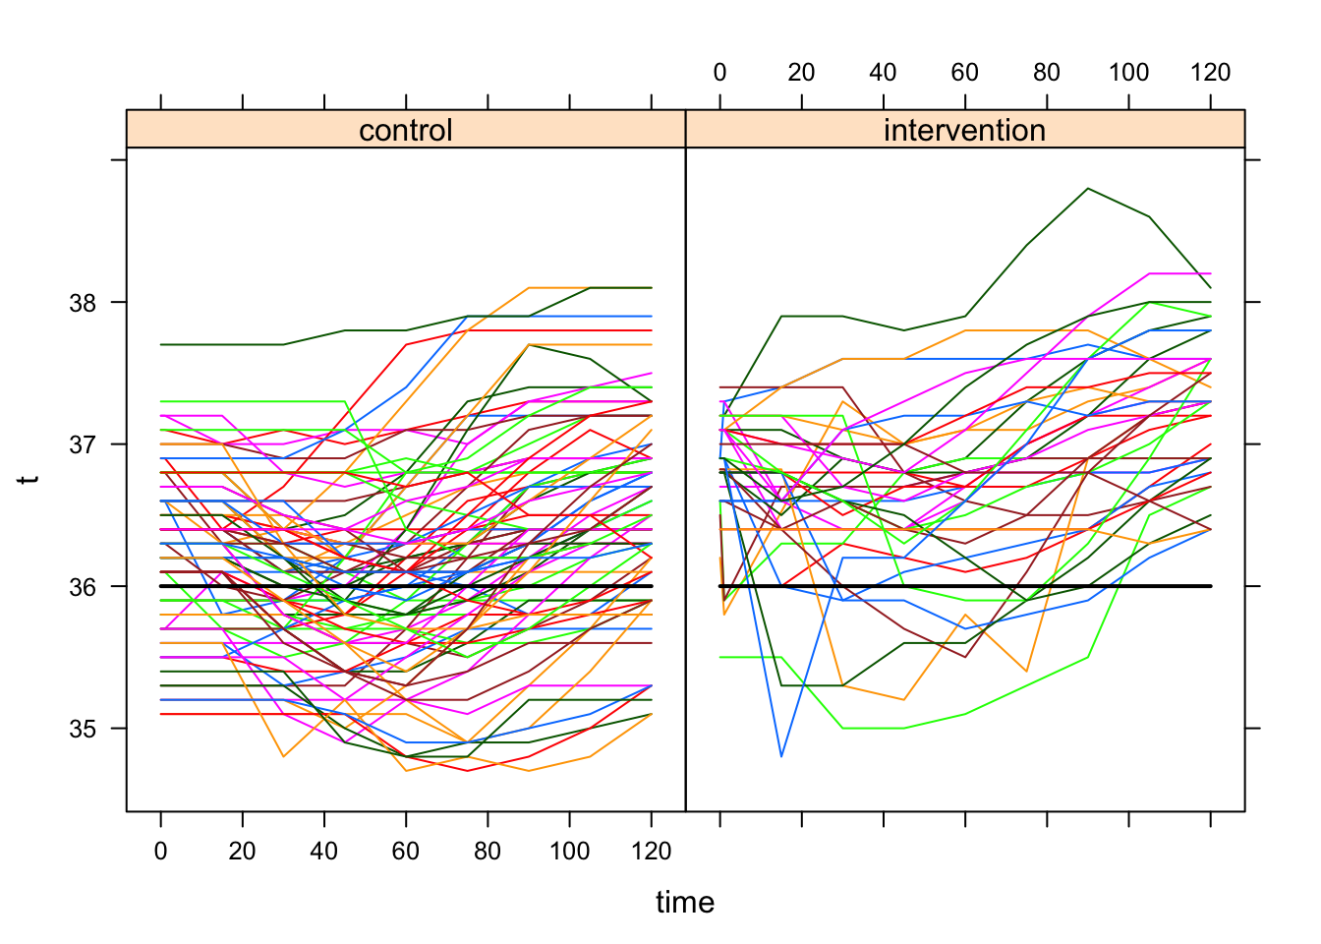

The following plot compares the actual hypothermic proportions to the model-based predictions for each arm of the study. The mixed effects logistic regression controls for age and prep time and reveals a decrease in hypothermia over time for both groups.

